Step 1: Add helm repo

helm repo add prometheus-community <https://prometheus-community.github.io/helm-charts>

Step 2: update helm repo

helm repo update

Step 3: list helm repo

helm repo list

Step 4: create a namespace

kubectl create ns monitoring

Step 5:deploy prometheus

helm upgrade prometheus prometheus-community/prometheus \

--install \

--namespace monitoring \

--set server.service.type=NodePort \

--set server.service.nodePort=30090 \

--set server.persistentVolume.enabled=false

Step 6.A : ensure all pods running state ( except for aletmanager as pending) Is okay

kubectl get pods -n monitoring

Step 6.B : Capture the nodeport

kubectl get svc -n monitoring

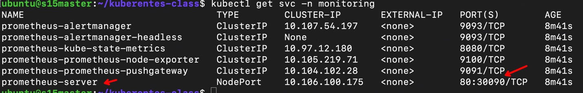

Visit the prometheus deployment <http://master-node-public-ip:30090/> on browser

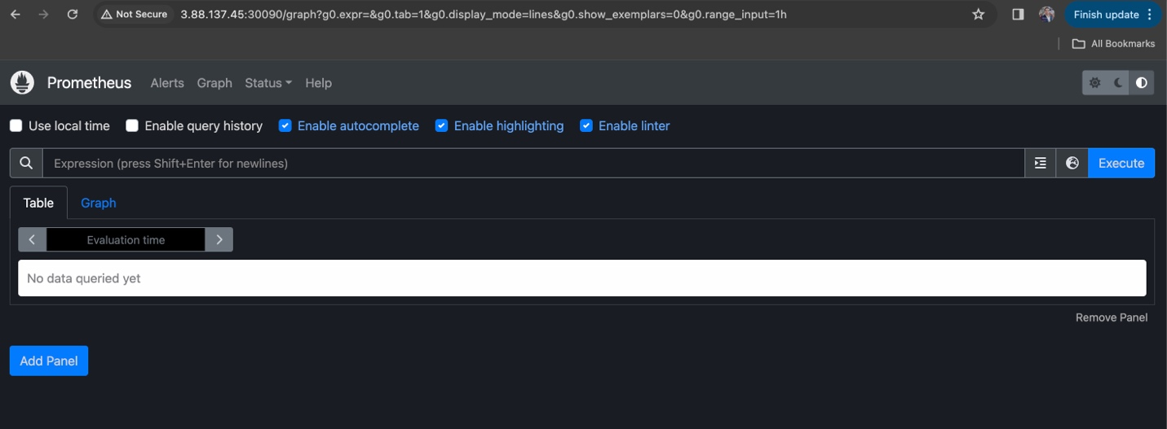

=========== lab completes ==============